# **Neon Anarchy: The Job Calendar**

## **What is it?**

The NA Job Calendar is a Google calendar which shows all upcoming Shadowruns in a nifty, simple-to-use schedule. It overlays your current mundane work meetings with scheduled runs involving corporate intrigue, magic and violence (or a dragon, which does all three at once) while set in a dystopian future!

**TLDR;** If you want to simply subscribe to this calendar, please go to section *Integrating the NA Job Calendar into your own environment* on page 5. The section *Gimme! I’ll buy two …* on page 3 provides you with other key calendar attributes.

## **How does it work?**

A bot interacts with reddit to parse (read) the job headings in /r/NeonAnarchy, then creates equivalent ‘events’ in a shared google calendar. Google provides multiple calendar integration options, which will allow you to get those events into the calendar on your device of choice!

But wait, there’s more!

Google calendar does the timezone translation for you. See a run at 0100 UTC but, like me, need to use the fingers on both hands to work out your local time? No problem - Google will do that calculation automagically, and will also allow you to set an alarm 10 minutes prior to any run so that your Johnson never gets grumpy.

## **What do we need from GMs when they post their runs?**

Computers are stupid, so they need a predictable format to read.

We need GMs to follow the rules laid out in the [Example Run metapost](https://reddit.com/r/NeonAnarchy/comments/hjq4ji/example_run_metaplot_if_any_name_of_run/) in /r/NeonAnarchy. If the GMs follow that format, everything will be happiness, flowers and fluffy bunnies. If not - there’s no guarantee that the bot will be able to understand it.

Explicitly, this means run titles should be:

* [Metaplot, if any] Name of Run. YYYY-MM-DD. HHMM UTC

Where YYYY is the year (eg. 2021); MM is the month (from 1 to 12); and DD is the day (from 1 to 31 - depending on month). HH and MM are the hours and minutes for the run in 24-hour UTC time. The metaplot (in the square brackets []) is optional.

Historically, the titles in the sub don’t strictly adhere to the format in the [Example Run metapost](https://reddit.com/r/NeonAnarchy/comments/hjq4ji/example_run_metaplot_if_any_name_of_run/) and are hard for the bot to understand. Some examples below.

### **“Good” Job Postings**

Here’s a good example that the bot was fine with:

* Help The H.E.N.C.H.M.A.N. 2021-8-13. 2300 UTC

Also pretty good:

* Learning To Walk Again. 2021-8-9. 130 UTC

TaCtiX started getting creative with periods instead of dashes. I updated the bot to cope:

* [Bloody Business] 'Neath the Sand and Steel 2021.08.21 @ 1400 UTC

Dammit Dusk! Okay - Dusk’s UK/Commonwealth date format is now also fine:

* Red Hot Cargo 21-08-2021 14:00 UTC

**Note:** the bot can’t handle both UK and US dates at the same time as it wouldn’t be able to work out if 9/11 was the Eleventh of September or the Ninth of November. I recommend sticking to the Neon Anarchy metapost format (International/ISO format of YYYY-MM-DD) so that all posts are consistent.

### **Job titles the bot (currently) can’t handle**

We need to draw the line somewhere so that the parser code doesn’t become too massive...

Are human-readable dates desirable?

* (Quantum Chess) Queen's Knight to Rogue One 2021 Aug 8th 18:00 UTC

Maybe? (Human-readable dates, no year):

* Krime Pays. 11 August, 2300 UTC.

Please stop (one of everything):

* A Package, Retrieved (2021, Sunday Aug 8th, 1400UTC)

### **Whoops - there is an error/typo in my job post title! Help!**

No problem!

If there’s a typo in your job title (given reddit doesn’t allow us to modify titles after submission), edit your post and drop a calendar hint somewhere into the post text. The bot will revisit the post on next-pass and will look for that hint, using the hint instead of the title.

To add a calendar hint, just cut/past from the below. Hints are of the format:

{CALENDAR_HINT: <title>}

Where the <title> is the expected format in the [Neon Anarchy meta post](https://reddit.com/r/NeonAnarchy/comments/hjq4ji/example_run_metaplot_if_any_name_of_run/) mentioned above. An example hint might look like this:

{CALENDAR_HINT: A Package, Retrieved 2021-08-08 1400 UTC}

Or, if the run had metaplot, you could put that in too:

{CALENDAR_HINT: [Dastardly Package Plans Metaplot] A Package, Retrieved 2021-08-08 1400 UTC}

If your hint is of the correct format, the bot message will edit its own ‘error message’ post, changing the text from the error message to a “Your job has been posted...” success message. You’ll then see your Job in the calendar.

If your error message hangs around - please double check that there’s only one hint and it is of the right format. Edit your post to update the hint as many times as you need, as the bot will check for changes each pass, updating the calendar each time.

Finally, PM me (/u/kajh on reddit or kajh#9617 on discord) if you need help.

## **Gimme! I’ll buy two ...**

Okay - you want the calendar? I’ll give you the calendar. Those important calendar link(s) are:

Browser:

https://calendar.google.com/calendar/embed?src=uddj9vesitj3igvlh36jkqd4k8%40group.calendar.google.com&ctz=Etc%2FGMT

CalendarID:

uddj9vesitj3igvlh36jkqd4k8@group.calendar.google.com

Public address for iCal-format calendars (like an iPhone’s native calendar):

https://calendar.google.com/calendar/ical/uddj9vesitj3igvlh36jkqd4k8%40group.calendar.google.com/public/basic.ics

## 

## **But … I don’t like/I have a feature suggestion …**

Ping /u/kajh on reddit or kajh#9617 on discord - all suggestions welcome.

On my short-term list of things to do will be to add ‘hints’ - allowing GMs to give the calendar a nudge (update date/time by editing their post to add a ‘hint’, correcting the date if they type it incorrectly into the post title, for example). **NOTE: done @ 2021-08-16.**

I’m also going to update security - I need to accommodate reddit’s 2-factor authentication to completely secure the bot account. (APIs just stop working if I turn 2FA on at the moment - I need to update my API authentication code to compensate.)

Once both are done, I will expand to handle the NeonRed subreddit if desired.

## **Source code and bot account portability**

I’ve written this bot to cater for me moving on/being run over by a bus - whatever.

I intend that the [NACalendarBot@gmail.com](mailto:NACalendarBot@gmail.com) Google and [/u/NAnarchyCalendarBot](https://reddit.com/u/NAnarchyCalendarBot) reddit accounts will remain with the NeonAnarchy leadership outside of myself (and will ultimately be managed by the tech admin team).

Source code for the bot and its test harness is in a bitbucket (git) repo and will be published in a future version of this document.

The bot is currently hosted on my home (Synology) NAS running python 3.8.x (after development on 3.9.x), but should be easily portable to any hosting environment.

## **A special thanks!**

This bot was inspired by [/u/UCuri](https://www.reddit.com/user/Ucuri/) who wrote the [original CalendarBot](https://www.reddit.com/r/RunnerHub/comments/2qt9yv/calendar_bot_v2/) used by /r/RunnerHub. Full credit to her/him/them! I took that code as a prototype and then significantly updated/refactored it/cleaned it up, adding a test harness and some more structure to ease maintenance in future.

It was a fun exercise over a lazy weekend in lockdown. Thanks COVID!

## 

## **Integrating the NA Job Calendar into your own environment**

If you would like to integrate the Job Calendar into your own calendaring environment, find an appropriate integration option below and follow the bouncing ball!

### **Integrate into your Google Calendar account (from the Job calendar itself)**

If you’re already using Google Calendar, this is the most-convenient option. Go to the Job calendar:

<https://calendar.google.com/calendar/embed?src=uddj9vesitj3igvlh36jkqd4k8%40group.calendar.google.com&ctz=Etc%2FGMT>

Click on the ‘+’ button at the bottom of the screen:

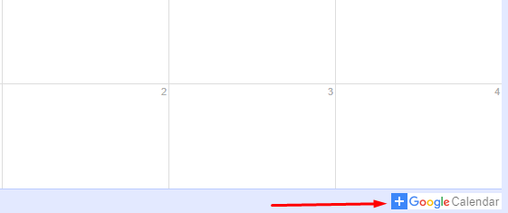

Click the ‘Add’ button:

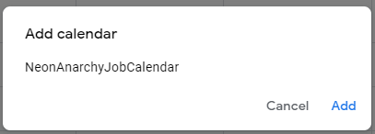

And … done! There may be a Google sign-in step in there, but I’m sure you can manage that.

### 

### **Integrate into your Google Calendar account (manually)**

If you would like to manually add this calendar to your Google Calendaring environment, sign into Google, go to your own Google calendar, and click on the ‘+’ button.

### 

From the pop-up menu, click on the ‘Subscribe to calendar’ option.

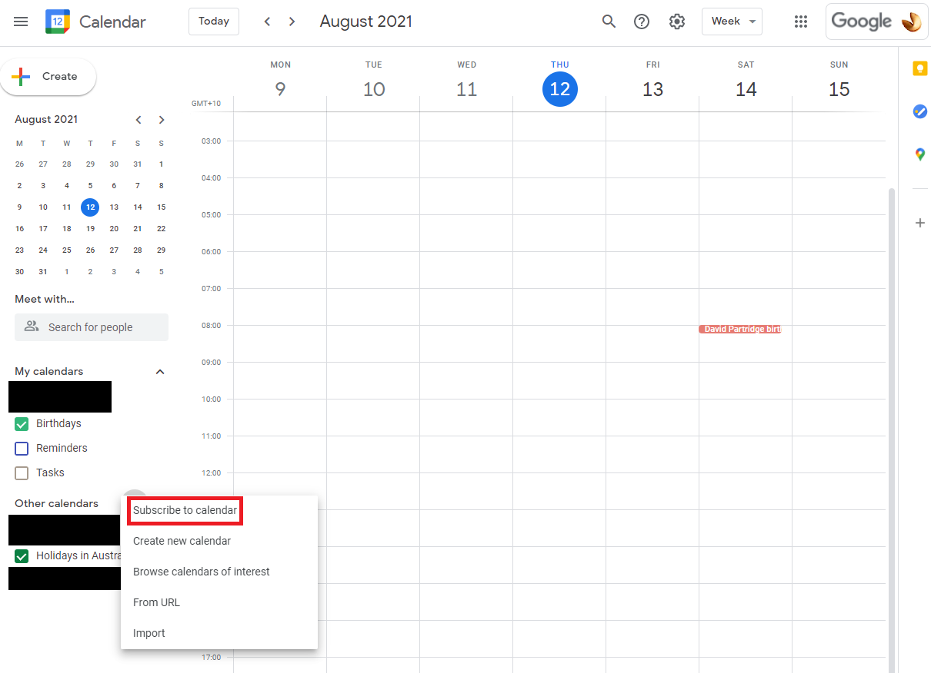

Paste in the CalendarID (uddj9vesitj3igvlh36jkqd4k8@group.calendar.google.com) into the ‘Add calendar’ field. Once done, hit ‘enter’.

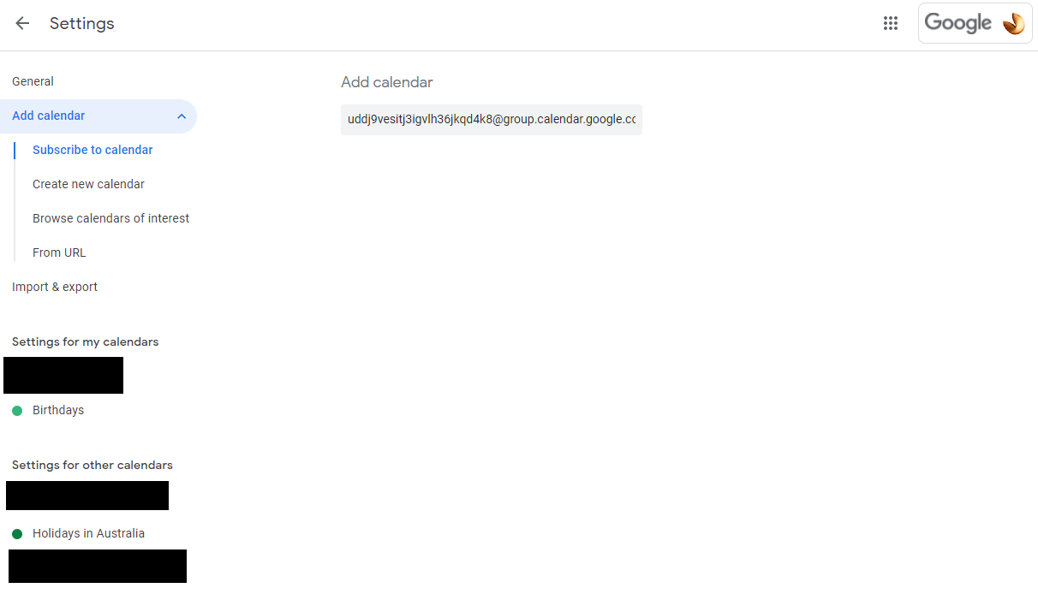

Well done! You should see the calendar configuration! Customise settings to your heart’s content. (**Tip:** setup alarms 10 minutes before Runs.)

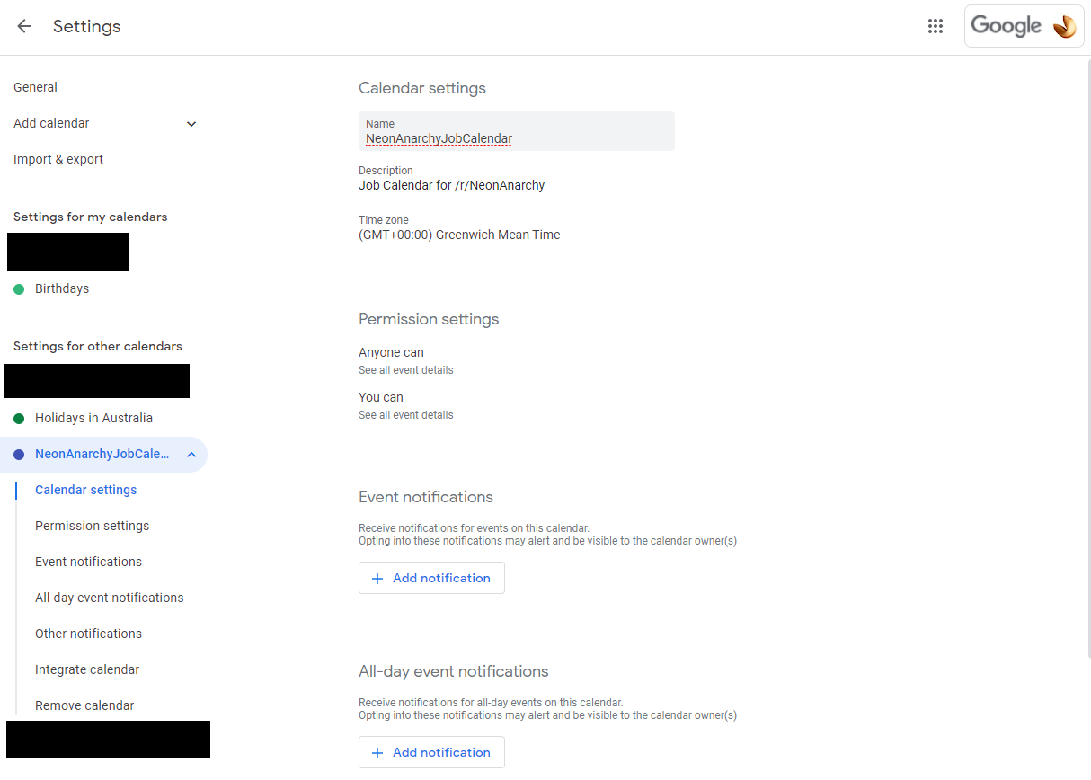

Once done, hit the ‘left arrow’ on the top-left corner of your screen, to see the calendar overlay in its full glory, with all runs localised to your local timezone. Pretty!

**Note 1:** The author is writing from Sydney/Australia - a particularly inconvenient timezone to the US and Europe. That said - all UTC Job times are automatically timeshifted into local/AEST time(s) - a setting of my own Google calendar instance.

**Note 2:** you can toggle on/off the Job Calendar if things get cluttered - just tick/untick the NeonAnarchyJobCalendar item in your list (bottom-left of the image below) as required.

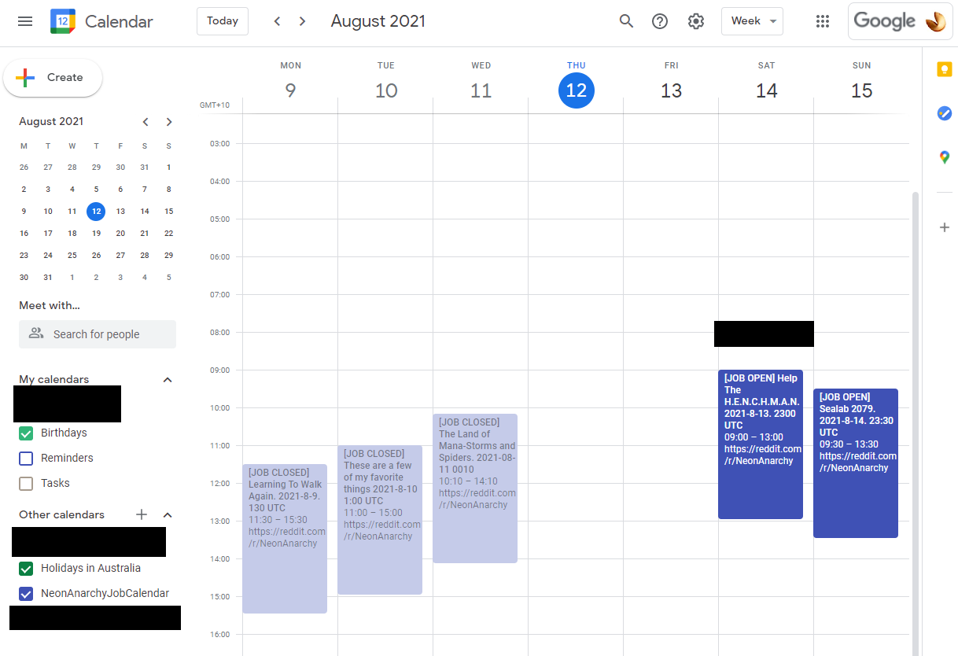

### **Add the native Google Calendar app to your phone!**

Once you’ve configured the calendars, you can easily view them in your Google Calendar app (iOS or Android) for free.

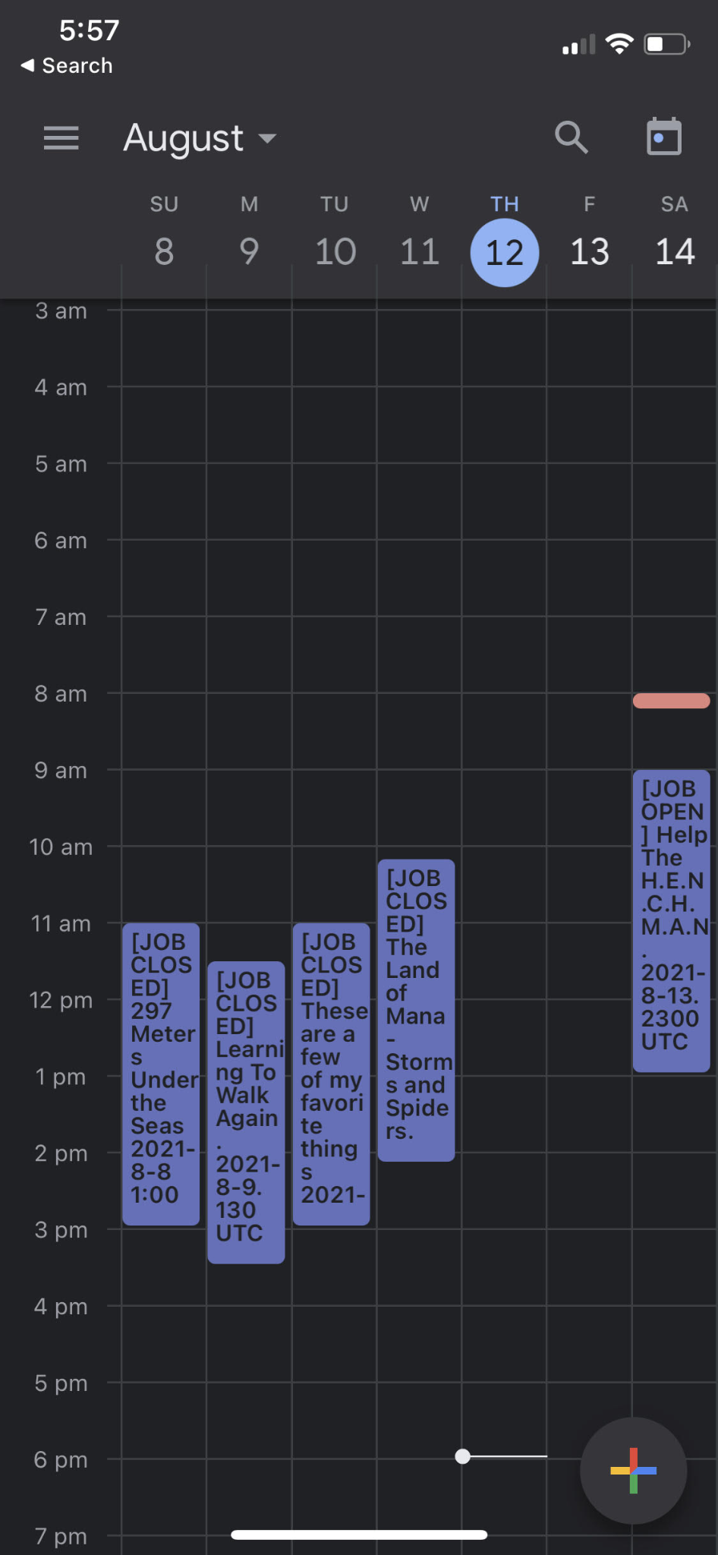

### **Integrate into your native iPhone calendar**

This article seems to have it covered (section ‘Set up a calendar account’). Use the iCal string at the top of this document.

<https://support.apple.com/en-au/guide/iphone/ipha0d932e96/ios>

**In detail:**

| Go to Settings / Calendar. | Click on ‘Accounts’. |
| --- | --- |
| Click ‘Add Account’. | Click ‘Other’. |
| Click ‘Add Subscribed Calendar’. | Enter the calendar .ics string, listed on page 3 of this doc. To make it easier, it is:  <https://calendar.google.com/calendar/ical/uddj9vesitj3igvlh36jkqd4k8%40group.calendar.google.com/public/basic.ics> |
| Copy the iCal string ... | … and paste into the Server field! Click ‘Next’. |
| Click ‘Save’. | You should see the new Subscribed Calendar (NeonAnarchyJobCalendar). |
| And done! Your calendar is good to go! |  |

### **Integrate into your native Android phone calendar**

TODO - if someone is able to help me out … :)

I believe Android uses Google Calendar natively (in which case - use instructions above), but … I don’t have an Android phone to test. Anyone able to help?

### **Integrate into some other calendar?**

Which other option(s) do you need?